MA176 Portfolio

By: Chris Callender

Players: Mark Teixeira and Frank Thomas

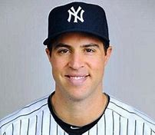 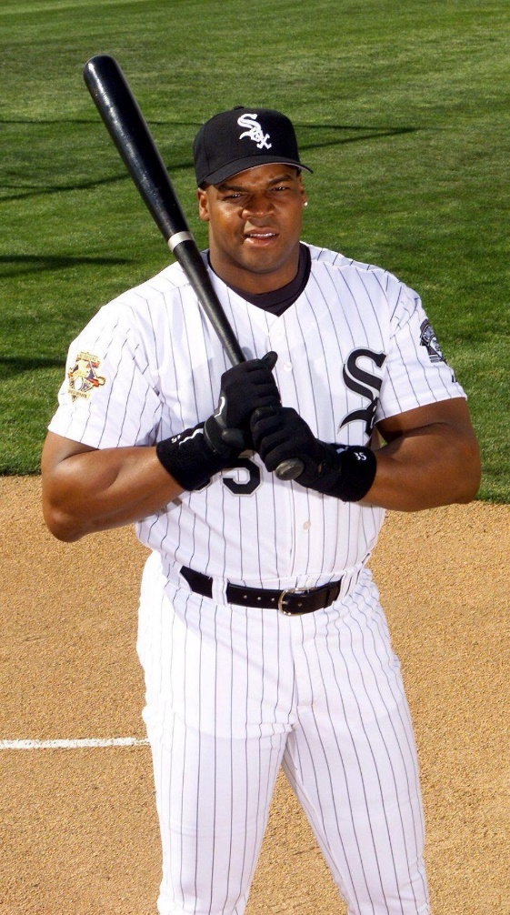

Table of Contents

1. Brief Introduction of Two Players
   1. Mark Teixeira 3
   2. Frank Thomas 4
2. Career Stats for Each Player
   1. Mark Teixeira 5
   2. Frank Thomas 6
3. Basket of Stats
   1. Table 4.3 7
   2. Table 4.5 8
   3. Table 4.6 8
   4. Table 4.7 9
   5. Figure 4.1 10
   6. Figure 4.2 11
   7. Figure 4.3 12
   8. Chapter 4 Write Up 13
4. Linear Regression
   1. Table 5.4 14
   2. Table 5.5 14
   3. Figure 5.3 15-18
   4. Table 5.6 19
   5. Table 5.7 19
   6. Figure 5.4 20-23
   7. Table 5.8 24
   8. Figure 5.5 24
   9. Chapter 5 Write Up 25
5. Percentage of Plate Appearances
   1. Table 6.2 26
   2. Figure 6.3 26
   3. Figure 6.4 26
   4. Figure 6.5 26
   5. Chapter 6 Write Up 27
6. Chapter 7
   1. Figure 7.4 28
   2. Figure 7.5 28
   3. Table 7.4 28
   4. Chapter 7 Write Up 29
7. Final Comparisons of Batting Performances of Teixeira and Thomas
   1. Figure 10.1 30
   2. Figure 10.2 30
   3. Figure 10.3 30
   4. Figure 10.4 30
   5. Table 10.4 31
   6. Figures 10.6-10.11 31-32
   7. Table 10.5—Black Ink Test 33
   8. Grey Ink Test 34
   9. Hall of Fame Standards Test 35
   10. Similarity Test 36
8. Final Argument 37

Mark Teixeira

Mark Teixeira played in MLB from 2003-2016. He played for the Texas Rangers, Atlanta Braves, Los Angeles Angels and New York Yankees. He was a 3-time all-star, won 5 gold gloves, 3 silver sluggers, lead the American League in home runs in 2009 as well as rbis that same year. Teixeira also won the world series in 2009 with the New York Yankees. He played a major role for the Yankees in both the regular season and the playoffs in 2009.

He was born on April 11, 1980 in Maryland. Teixeira was first drafted by the Boston Red Sox in the ninth round of the 1998 draft. However, he decided to play baseball for Georgia Tech. In 2001 Teixeira was drafted fifth overall by the Texas Rangers.

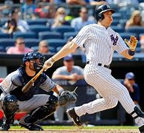 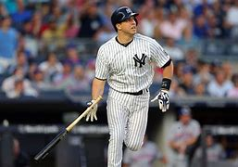

Frank Thomas

Frank Thomas, also known as “The Big Hurt”, played in MLB from 1990-2008 for the Chicago White Sox, Oakland Athletics and Toronto Blue Jays. He was a 5-time all-star, won 4 silver sluggers, won the batting title in 1997 and won the 1993 and 1994 AL MVP. Thomas was elected to the Hall of Fame in 2014 with 83.7% of the vote. That was his first year on the ballot.

He was born on May 27, 1968 in Georgia. Thomas played both baseball and football in high school and played both sports very well. He hit .440 his senior year and was named an All State tight end. Thomas was drafted by the Chicago White Sox with the seventh overall pick.

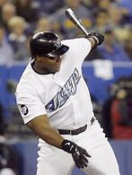 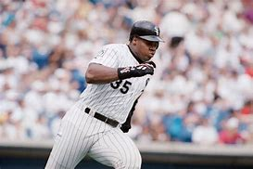





|  |  |  |  |  |  |  |
| --- | --- | --- | --- | --- | --- | --- |
| Table 4.3 | Yearly BA, OBP, SLG for Teixeira and Thomas | | | | | |
|  | BA | | OBP | | SLG | |
| Year | Teixeira | Thomas | Teixeira | Thomas | Teixeira | Thomas |
| 1 | 0.259 | 0.330 | 0.331 | 0.454 | 0.480 | 0.529 |
| 2 | 0.281 | 0.318 | 0.370 | 0.453 | 0.560 | 0.553 |
| 3 | 0.301 | 0.323 | 0.379 | 0.439 | 0.575 | 0.536 |
| 4 | 0.282 | 0.317 | 0.371 | 0.426 | 0.514 | 0.607 |
| 5 | 0.306 | 0.353 | 0.401 | 0.487 | 0.570 | 0.729 |
| 6 | 0.308 | 0.308 | 0.420 | 0.454 | 0.572 | 0.606 |
| 7 | 0.292 | 0.349 | 0.383 | 0.459 | 0.565 | 0.626 |
| 8 | 0.256 | 0.347 | 0.365 | 0.456 | 0.481 | 0.611 |
| 9 | 0.248 | 0.265 | 0.341 | 0.381 | 0.494 | 0.480 |
| 10 | 0.251 | 0.305 | 0.332 | 0.414 | 0.475 | 0.471 |
| 11 | 0.216 | 0.328 | 0.313 | 0.436 | 0.398 | 0.625 |
| 12 | 0.255 | 0.221 | 0.357 | 0.316 | 0.548 | 0.441 |
| 13 | 0.204 | 0.252 | 0.292 | 0.361 | 0.362 | 0.472 |
| 14 |  | 0.267 |  | 0.390 |  | 0.562 |
| 15 |  | 0.271 |  | 0.434 |  | 0.563 |
| 16 |  | 0.219 |  | 0.315 |  | 0.590 |
| 17 |  | 0.270 |  | 0.381 |  | 0.545 |
| 18 |  | 0.277 |  | 0.377 |  | 0.480 |
| 19 |  | 0.240 |  | 0.335 |  | 0.360 |

|  |  |  |  |  |  |  |  |
| --- | --- | --- | --- | --- | --- | --- | --- |
| Table 4.5 | Descriptive Measures for Yearly BA, OBP and SLG for Teixeira and Thomas | | | | | | |
| Descriptive | BA | | OBP | | SLG | |  |
| Measure | Teixeira | Thomas | Teixeira | Thomas | Teixeira | Thomas |  |
| Mean | 0.258 | 0.293 | 0.358 | 0.409 | 0.507 | 0.547 |  |
| Standard Error | 0.012 | 0.010 | 0.010 | 0.012 | 0.019 | 0.019 |  |
| Median | 0.258 | 0.305 | 0.365 | 0.426 | 0.514 | 0.553 |  |
| Mode | #N/A | #N/A | #N/A | 0.454 | #N/A | 0.480 |  |
| Standard Deviation | 0.044 | 0.043 | 0.036 | 0.051 | 0.068 | 0.084 |  |
| Sample Variance | 0.002 | 0.002 | 0.001 | 0.003 | 0.005 | 0.007 |  |
| Kurtosis | 1.336 | -1.088 | -0.230 | -0.775 | 0.251 | 0.656 |  |
| Skewness | -1.121 | -0.260 | -0.169 | -0.536 | -0.983 | -0.137 |  |
| Range | 0.157 | 0.134 | 0.128 | 0.172 | 0.213 | 0.369 |  |
| Minimum | 0.151 | 0.219 | 0.292 | 0.315 | 0.362 | 0.360 |  |
| Maximum | 0.308 | 0.353 | 0.420 | 0.487 | 0.575 | 0.729 |  |
| Sum | 3.610 | 5.560 | 4.655 | 7.768 | 6.594 | 10.386 |  |
| Count | 14 | 19 | 13 | 19 | 13 | 19 |  |

|  |  |  |  |  |  |  |  |  |
| --- | --- | --- | --- | --- | --- | --- | --- | --- |
| Table 4.6 | Five Number Summary of BA, OBP, and SLG for Teixeira and Thomas | | | | | | | |
|  | BA | | OBP | | SLG | |  |  |
|  | Teixeira | Thomas | Teixeira | Thomas | Teixeira | Thomas |  |  |
| Smallest | 0.204 | 0.219 | 0.292 | 0.315 | 0.362 | 0.360 |  |  |
| Q1 | 0.250 | 0.265 | 0.332 | 0.377 | 0.478 | 0.480 |  |  |
| Q2 | 0.259 | 0.305 | 0.365 | 0.426 | 0.514 | 0.553 |  |  |
| Q3 | 0.297 | 0.328 | 0.381 | 0.454 | 0.568 | 0.607 |  |  |
| Largest | 0.308 | 0.353 | 0.420 | 0.487 | 0.575 | 0.729 |  |  |
| IQR | 0.047 | 0.063 | 0.050 | 0.077 | 0.090 | 0.127 |  |  |
| K For Outlier Fence | 0.071 | 0.095 | 0.074 | 0.116 | 0.135 | 0.191 |  |  |
| Lower Value | 0.179 | 0.171 | 0.257 | 0.262 | 0.343 | 0.290 |  |  |
| Upper Value | 0.367 | 0.423 | 0.455 | 0.570 | 0.703 | 0.798 |  |  |
| Outliers | 0.151 | None | None | None | 0.340 | None |  |  |

|  |  |  |  |  |  |  |
| --- | --- | --- | --- | --- | --- | --- |
| Table 4.7 | Sorted Yearly BA, OBP, and SLG for Teixeira and Thomas | | | | | |
|  | BA | | OBP | | SLG | |
| Position | Teixeira | Thomas | Teixeira | Thomas | Teixeira | Thomas |
| 1 | 0.204 | 0.219 | 0.292 | 0.315 | 0.362 | 0.360 |
| 2 | 0.216 | 0.221 | 0.313 | 0.316 | 0.398 | 0.441 |
| 3 | 0.248 | 0.240 | 0.331 | 0.335 | 0.475 | 0.471 |
| 4 | 0.251 | 0.252 | 0.332 | 0.361 | 0.480 | 0.472 |
| 5 | 0.255 | 0.265 | 0.341 | 0.377 | 0.481 | 0.480 |
| 6 | 0.256 | 0.267 | 0.357 | 0.381 | 0.494 | 0.480 |
| 7 | 0.259 | 0.270 | 0.365 | 0.381 | 0.514 | 0.529 |
| 8 | 0.281 | 0.271 | 0.370 | 0.390 | 0.548 | 0.536 |
| 9 | 0.282 | 0.277 | 0.371 | 0.414 | 0.560 | 0.545 |
| 10 | 0.292 | 0.305 | 0.379 | 0.426 | 0.565 | 0.553 |
| 11 | 0.301 | 0.308 | 0.383 | 0.434 | 0.570 | 0.562 |
| 12 | 0.306 | 0.317 | 0.401 | 0.436 | 0.572 | 0.563 |
| 13 | 0.308 | 0.318 | 0.420 | 0.439 | 0.575 | 0.590 |
| 14 |  | 0.323 |  | 0.453 |  | 0.606 |
| 15 |  | 0.328 |  | 0.454 |  | 0.607 |
| 16 |  | 0.330 |  | 0.454 |  | 0.611 |
| 17 |  | 0.347 |  | 0.456 |  | 0.625 |
| 18 |  | 0.349 |  | 0.459 |  | 0.626 |
| 19 |  | 0.353 |  | 0.487 |  | 0.729 |





Chapter 4 Write Up

The descriptive measures for Teixeira and Thomas with respect to yearly BAs are similar, but Thomas has a slight edge over Teixeira with respect to BA.

The mean BA for Teixeira is .258 and the mean BA for Thomas is .293. That is a significant difference in terms of batting average, so Thomas has an edge over Teixeira with respect to mean BA.

The standard deviation for Teixeira is .044 and the standard deviation for Thomas is .043. The standard deviations are close. This means that both players had consistency in their yearly batting averages.

Based on the five-number summary, the median for Teixeira is .258 and the median for Thomas is .305. The interquartile range for Teixeira is .044 and the interquartile range for Thomas is .063.

Based on the stem and leaf graph, the longest stem for Teixeira is .25 and the longest stem for Thomas is .27. The estimated mode for Teixeira is .255 and the estimated mode for Thomas is .273.

Based on the time series graph, throughout both player’s careers, Thomas’ performance was better. They both declined slightly as they got older, but overall, Thomas had better performance throughout his career.

Considering their career years, Thomas’ performance based on yearly batting average was superior.



|  |  |  |  |
| --- | --- | --- | --- |
| Table 5.5 Teixeira | | | |
| Variable | Rank | r^2 | r |
| OBP | 1 | 0.8202 | 0.91 |
| BRA | 2 | 0.7852 | 0.89 |
| RC/27 | 3 | 0.7825 | 0.88 |
| OPS | 4 | 0.7787 | 0.88 |
| BA | 5 | 0.7320 | 0.86 |
| SLG | 6 | 0.7066 | 0.84 |
| ISO | 7 | 0.4858 | 0.70 |

Figure 5.3 Teixeira



|  |  |  |  |
| --- | --- | --- | --- |
| Table 5.7 Thomas | | | |
| Variable | Rank | r^2 | r |
| BRA | 1 | 0.9018 | 0.95 |
| RC/27 | 2 | 0.8911 | 0.94 |
| OPS | 3 | 0.8897 | 0.94 |
| SLG | 4 | 0.7599 | 0.87 |
| OBP | 5 | 0.7549 | 0.87 |
| BA | 6 | 0.6680 | 0.82 |
| ISO | 7 | 0.3528 | 0.59 |

Figure 5.4 Thomas



Chapter 5 Write Up

When it comes to Linear Regression, Teixeira and Thomas are different. Teixeira scored highest on OBP and Thomas scored highest on BRA. OBP was rank 5th for Thomas. However, one similarity is that ISO was the lowest for both players. Teixeira’s highest r value was .91 (OBP) and his lowest was .70 (ISO). Thomas’ highest r value was .95 (BRA) and his lowest was .59 (ISO). Teixeira’s r-squared for BA and OBP is higher than Thomas’, and Thomas’ r-squared for SLG is higher than Teixeira’s. SLG is rank four for Thomas and rank six for Teixeira. This means that Thomas is more of a power hitter than Teixeira.

This means that OBP is the best predicator for runs scored for Teixeira and BRA is the best predictor for runs scored for Thomas. Figure 5.5 shows the ordered pairs for the r-squared values for Teixeira and Thomas, along with the regression line for the ordered pairs. The r-squared value is .8238, which means there is a strong positive correlation between the x variable consisting of the r-squared numbers for Teixeira and the y variable consisting of the corresponding r-squared numbers for Thomas.



Chapter 6 Write Up

When looking at the side by side, stacked, and 100% stacked bar graphs, you can see that the variables are independent, but they are not perfectly independent. This is because even if a player and the outcome of plate appearance are independent, we would not expect perfect independence. If the player and the plate appearance outcome were perfectly independent, the side by side bar graphs and stacked bar graphs would be the same height. The 100% stacked bar graph would show the percentage of each outcome is 50%. This is not what Teixeira and Thomas’ graphs look like, so they are not perfectly independent. However, since the differences in percentages are not that large, the differences can be attributed to chance, so the variables are independent.



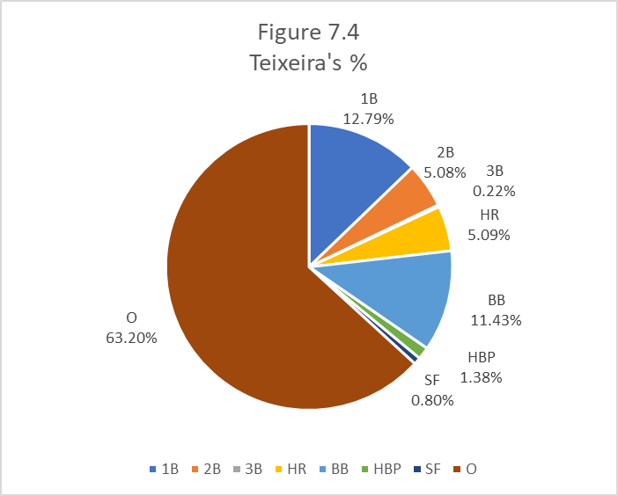

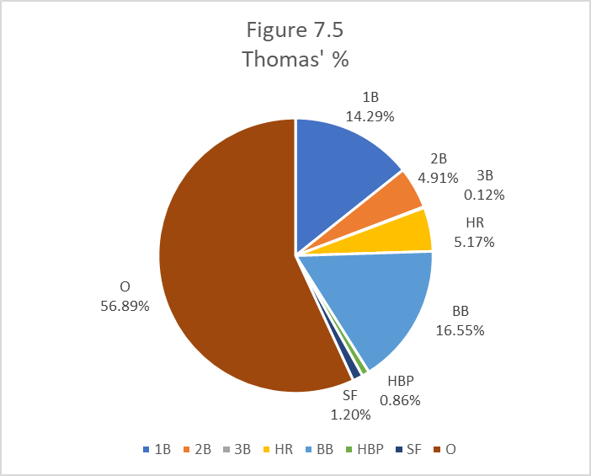

Chapter 7 Write Up

According to the frequency table for outcomes of plate appearances, Teixeira had a higher percentage of doubles, triples, HBP, and outs. Thomas had a higher percentage of singles, HR, BB, and SF. The biggest differences are walks and outs, which means that they are dependent and there is a relationship between the variables.

Teixeira’s plate appearances resulted in an out 63.20% of the time compared to 56.89% for Thomas. Also, Teixeira’s plate appearances resulted in walks 11.43% of the time compared to 16.55% for Thomas. Thomas also recorded a higher percentage of singles. 14.29% of his plate appearances resulted in singles and 12.79% of Teixeira’s plate appearances resulted in singles. This explains the difference in the percentage of outs. Thomas reached base via base on balls and singles more times than Teixeira, thus leading to a fewer number of outs. The percentages for the other categories are all very similar, which means they are independent, and the differences can be attributed to chance. They are both very similar hitters, but Thomas has an edge over Teixeira with respect to getting on base, due to a higher number of singles and walks.











Final Argument

I do not think that Mark Teixeira should be in the Hall of Fame. Teixeira is not as good a hitter as Frank Thomas when comparing their yearly stats, time series graphs, and descriptive measures. Thomas’ mean BA, OBP, and SLG is much higher than Teixeira’s.

The black ink test, grey ink test and hall of fame standards test show that Mark Teixeira does not meet Hall of Fame expectations. While it is not required to have a score of 27 on the black ink test, or a 144 on the grey ink test, Teixeira’s scores of 13 and 84 are not close, which means he is not close to the expectations. Even though Thomas did not meet expectations for the black ink, he got a score of 200 on the grey ink, which is much higher than the expectation for a Hall of Fame player. This indicates that although Thomas did not excel at leading the league, he did excel at being in the top ten.

Although Teixeira was an excellent defensive first baseman, and he was a key part of the Yankees’ 2009 World Series, his offense does not belong in the Hall of Fame. Also, Keith Hernandez won the most gold gloves of all time (he won 11). Even though he was an excellent defender, he is not in the Hall of Fame either.

In conclusion, Mark Teixeira was a good baseball player and very popular Yankees player, however, he does not belong in the Hall of Fame.